System Info: 192.168.1.72

Username: - manish.waghmare

Password: - Virtual%56

API Documentation for ATM_RECON using python

Updated Project Path: D:\manish_projects\MANISH_VGIPL_PROJECTS\ATM_RECON_SERVER_AND_CLIENT\Rest_Api_Service

# Folder structure in project directory

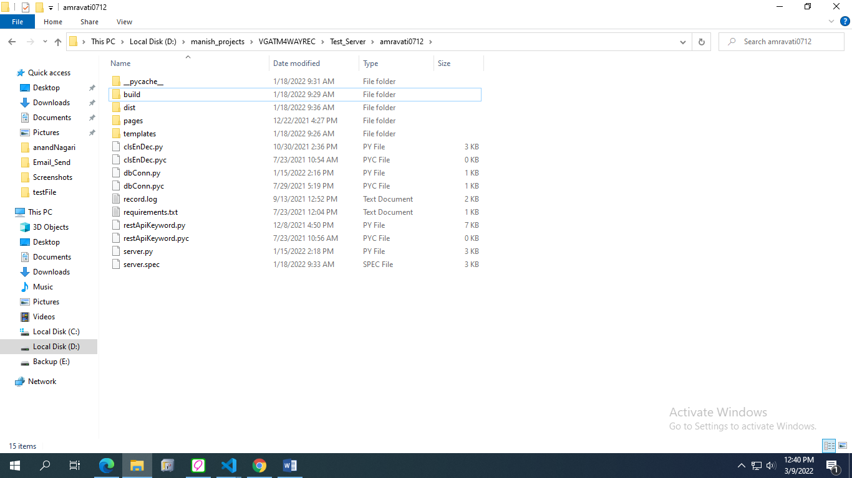

# Above image show dbConn.py file this file use for database connection

# Then inside page folder there are different procedure that are used in project

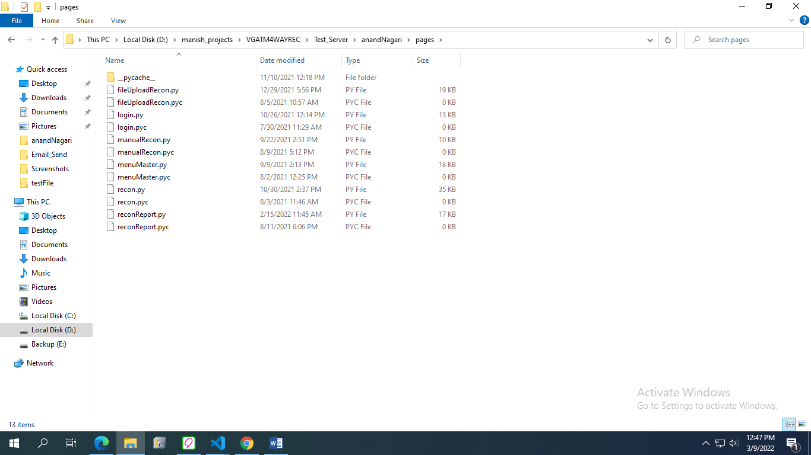

File Name: fileUploadRecon.py

Working:

1. It consist of procedure which is used to upload file that is single or in bulk to database.

File Name: recon.py

Working:

1. It consist of procedure which is used manual auto recon and posted un-posted transaction.

File Name: reconReport.py

Working:

1. It consist of procedure which is used reject transaction report, recon non-recon report, reference number all record report and Ej-log details report.

# When run this project use below command

python server.py

**if error as pyinstaller is not recognize**

You can always reinstall pyinstaller:

python -m pip uninstall pyinstaller

[output of uninstall]

python -m pip install pyinstaller

# When Create Build or exe file below command

pyinstaller server.py --onefile --add-data "templates";"templates" --add-data "amravatiZP";"amravatiZP"

Note: pass the same project name in the command as passed in ng build --base-href=/amravatiZP/ command.

API Documentation for VGMIS_CBS (Welfare Module) using python

Updated Project Path:

D:\manish_projects\MANISH_VGIPL_PROJECTS\WELFARE_SERVER_AND_CLIENT\VG_MIS_Rest_Api_Service

# Folder structure in project directory

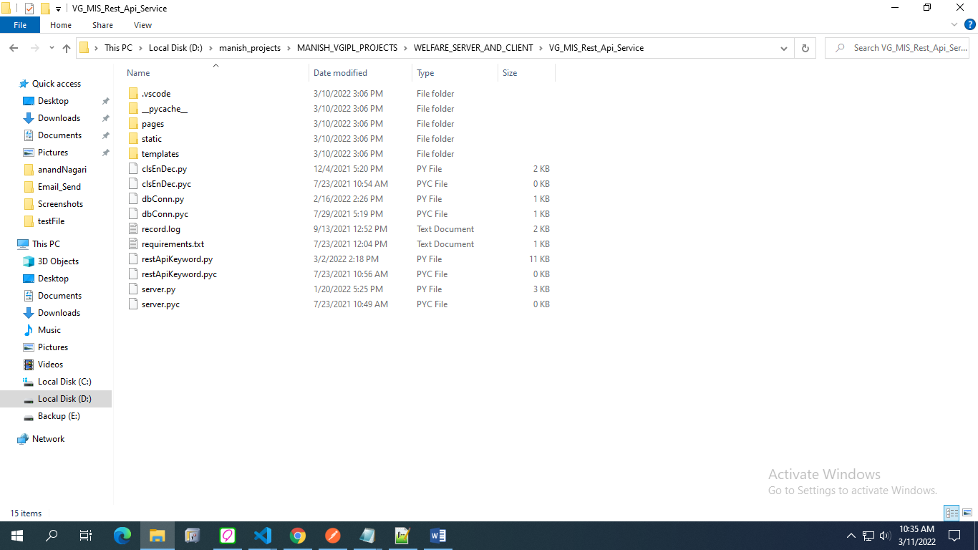

# Above image show dbConn.py file this file use for database connection

# Then inside page folder there are different procedure that are used in project

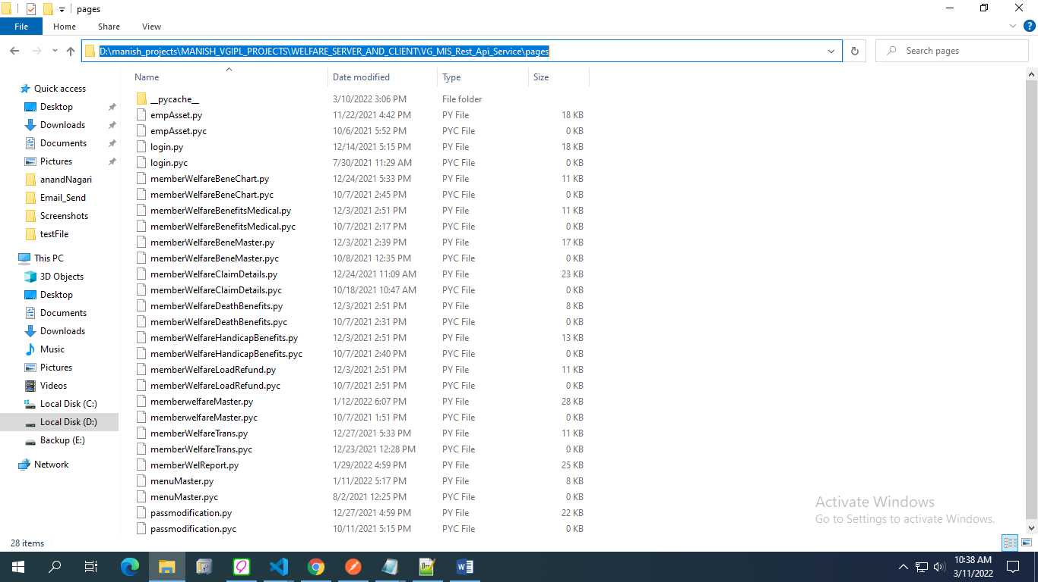

File Name: memberwelfareMaster.py

Working:

1. It consist of procedure which is used to create, modify, browse, authorize and reject to welfare master page.

File Name: memberWelfareBeneMaster.py

Working:

1. It consist of procedure which is used to create, modify, browse, authorize and reject to welfare benefit master page.

File Name: memberWelfareBeneChart.py

Working:

1. It consist of procedure which is used to create, modify, browse, authorize and reject to welfare benefit chart page.

File Name: memberWelfareDeathBenefits.py

Working:

1. It consist of procedure which is used to create, modify, browse, authorize and reject to welfare death benefit page.

File Name: memberWelfareHandicapBenefits.py

Working:

1. It consist of procedure which is used to create, modify, browse, authorize and reject to welfare handicap benefit page.

File Name: memberWelfareBenefitsMedical.py

Working:

1. It consist of procedure which is used to create, modify, browse, authorize and reject to welfare benefit medical page.

File Name: memberWelfareLoadRefund.py

Working:

1. It consist of procedure which is used to create, modify, browse, authorize and reject to welfare member load refund page.

File Name: memberWelfareTrans.py

Working:

1. It consist of procedure which is used to create, modify, browse, authorize and reject to welfare member transaction page.

File Name: memberWelfareClaimDetails.py

Working:

1. It consist of procedure which is used to create, modify, browse, authorize and reject to welfare member claim details page.

File Name: memberWelReport.py

Working:

1. It consist of procedure which is used to member welfare master report and welfare member claim details report.

# When run this project use below command

python server.py

# When Create Build or exe file below command

pyinstaller server.py --onefile --add-data "templates";"templates" --add-data "yashomandir";"yashomandir"

Note: pass the same project name in the command as passed in ng build --base-href=/yashomandir/ command.

API Documentation for Berar Finance using python

Updated Project Path:

D:\manish_projects\MANISH_VGIPL_PROJECTS\BERAR_SERVICE_AND_CLIENT\rest-api

D:\manish_projects\MANISH_VGIPL_PROJECTS\BERAR_SERVICE_AND_CLIENT\server

# When run this project use below command

python script.py

API Documentation for VPAY_CORP using node (Scheduler)

Updated Project Path:

D:\manish_projects\MANISH_VGIPL_PROJECTS\VPAY_CORP

# When run this project use below command

node app.js

API Documentation for Berar Finance using python

Updated Project Path:

D:\manish_projects\MANISH_VGIPL_PROJECTS\BERAR_SERVICE_AND_CLIENT\rest-api

D:\manish_projects\MANISH_VGIPL_PROJECTS\BERAR_SERVICE_AND_CLIENT\server

# First we start server

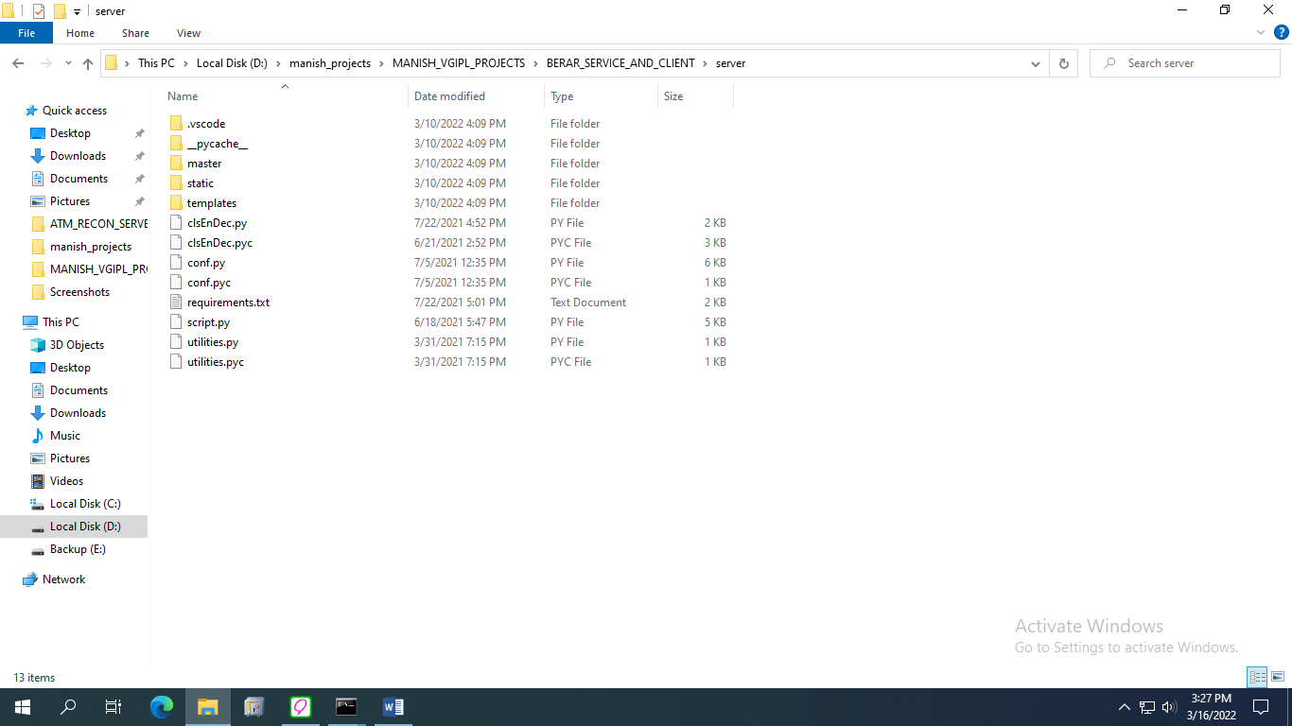

Then inside master folder find requestSent.py this file use for to redirect to rest api sever.

After successfully start server then we start rest-api server.

# When run this server use below command

python script.py

# Below image is rest api server, when request hit from server goes to this rest-api and database methods defined in this rest api get called.

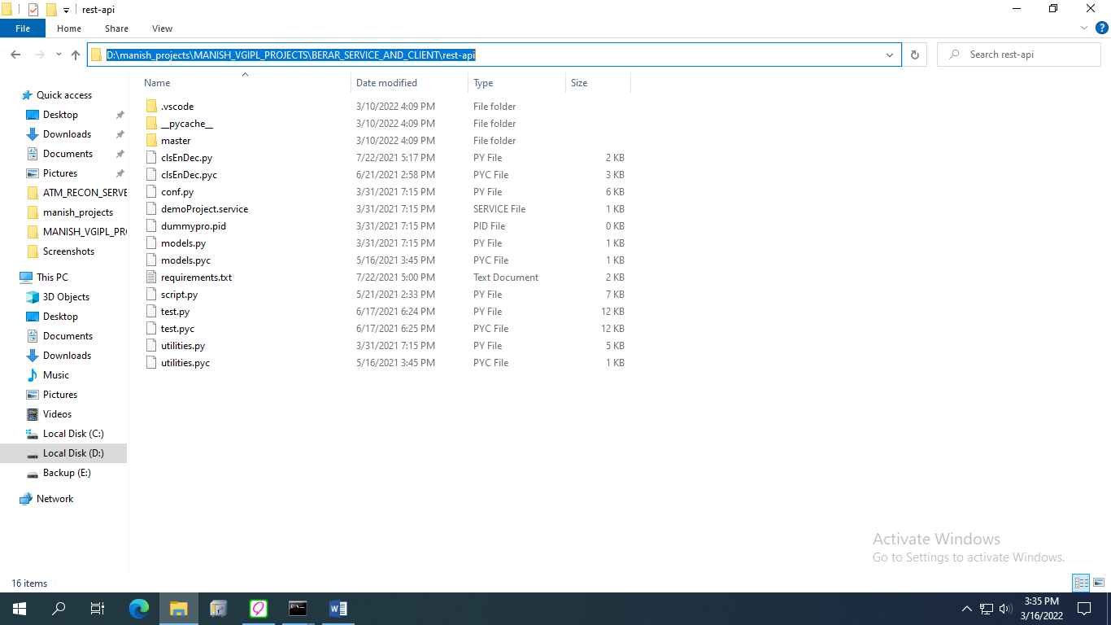

# when run this rest-api server use below command

python script.py